Infographic Outline Sample

Advantages to Online Courses

Quick Facts

MOOC (massive open online course) – “a course of study made available over the Internet without charge to a very large number of people”

6.7 Million or 45% – Number of students taking at least one online course, according to 2013 College Explorer report.

Badges – online certificates that represent different levels of work and engagement, including more granular, specific skills or achievements.

Mobile Learning – Modern access to skill building courses from smartphones and tablets
- 13 percent of students report taking class notes on their smartphones
- 33 percent said they use tablets for work, research, and taking notes, and 37 percent said they read e-textbooks on them

Effectiveness

Research shows that online students achieve same or better learning results in about half the time as those in traditional courses.

It also “indicates that students are more active, engaged, and motivated, when working with coursework that is challenging but within their capacity to master.”

Advantages

- Tangible Skill Building:
    - Improved attitude toward learning
    - Proof of skills gained to advance career, e.g., badges
    - Higher course completion rates, up to 92% in some cases
    - Online literacy gains

- Varied, Useful Courses--Over 70,000 courses from 300+ providers:
    - Building Websites
    - WordPress
    - Java Programming
    - Adobe Photoshop
    - Content Marketing
    - Android Programming
    - Creative Writing
    - Business Law
    - Business Plan Writing
    - Many More

- Specialized Courses/Certificates –According to Sarah Jane Walshe in her article “Digital Badges Finding Use in Education and Across Industries,” certificates and badges can be offered to “motivate and reward achievement” as well as provide “widely-accepted recognition to an individual’s development.”
  - Courses include:
    - Data Science
    - Entrepreneurship
    - Web programming
    - Cyber Security
    - Reasoning
    - Technical Writing
    - Many More

- Reduced Costs:
  - Less or no commuting
  - Included course materials
  - Included online textbooks – or none at all
  - Reduced or free tuition
    - Costs range from free to relatively small payments per month.

- Learning Style Flexibility:
  - Learn when you want to.
  - Learn where you want to:
    - At home
    - On vacation
    - At work (discretely)
    - Anywhere with Internet connection
  - Learn how you want to:
    - Unique learning style
    - Individual pace

- Accessibility:
  - 24/7 Internet access, anywhere
  - Support for visually impaired, deaf, homebound and others with physical limitations
  - Mobile Access – According to the Pew Internet & American Life Project
    - 85% of adults have cell phones,
    - 82% of all U.S. adults age 18 and older say that they use the Internet or e-mail at least occasionally,
    - 67% do so on a typical day

- Cutting-Edge Technology:
    - Virtual classrooms
    - Discussion forums
    - Online texts and libraries
    - Video lectures
    - Class calendars
    - Wikis
    - Web video

- Better Teaching Quality:
  - Teachers are often trained by educational technology experts.
  - Courses often taught by experts with field experience.
  - Multimedia teaching techniques are used.
  - Courses are usually better organized than traditional courses.

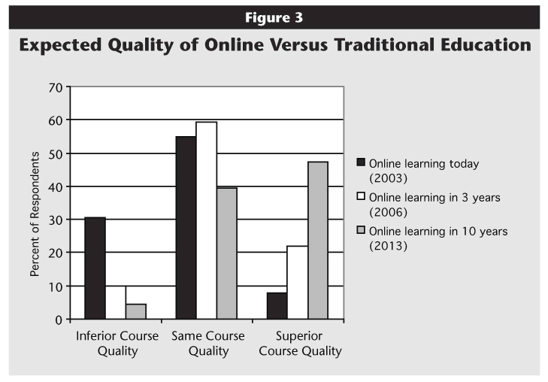

Availability

- Check out websites devoted to skill building!
- Most online programs accept students from all over the world, so don’t be shy!
- Browse the courses offered and decided how much time and effort you can afford.
  - Research topics that interest you.
  - Determine whether or not the courses are free or not.
  - Be specific!

Sources

http://www.huffingtonpost.com/tom-snyder/the-benefits-of-online-le_b_2573991.html

http://www.educause.edu/ero/article/future-online-teaching-and-learning-higher-education-survey-says%E2%80%A6

http://oedb.org/ilibrarian/10-advantages-to-taking-online-classes/

http://blackboardsupport.calpoly.edu/content/faculty/handouts/Ben_Online.pdf

https://www.coursera.org/about/

http://www.skilledup.com/about/

http://edtech2.boisestate.edu/sabaa/502/Saba_Synthesis_Paper.pdf

http://everydaylife.globalpost.com/online-classes-10238.html

http://www.babson.edu/news-events/babson-news/pages/130107-2012-survey-of-online-learning-results.aspx

http://oli.cmu.edu/wp-oli/wp-content/uploads/2012/05/Lovett_2008_Statistics_Accelerated_Learning_Study.pdf

http://harvardmagazine.com/2013/09/harvardx-edx-and-moocs-prove-effective

http://www.usnews.com/education/online-education/articles/2012/07/25/study-online-learning-outcomes-similar-to-classroom-results

https://net.educause.edu/ir/library/pdf/ELI7105.pdf

http://campustechnology.com/articles/2013/06/24/report-students-taking-online-courses-jumps-96-percent-over-5-years.aspx

http://www.extremenetworks.com/digital-badges-finding-use-in-education-and-across-industries/

